Types of Rhyme within Couplets
# Source: Chatgpt (GPT-4-turbo) at [8/2/2025]
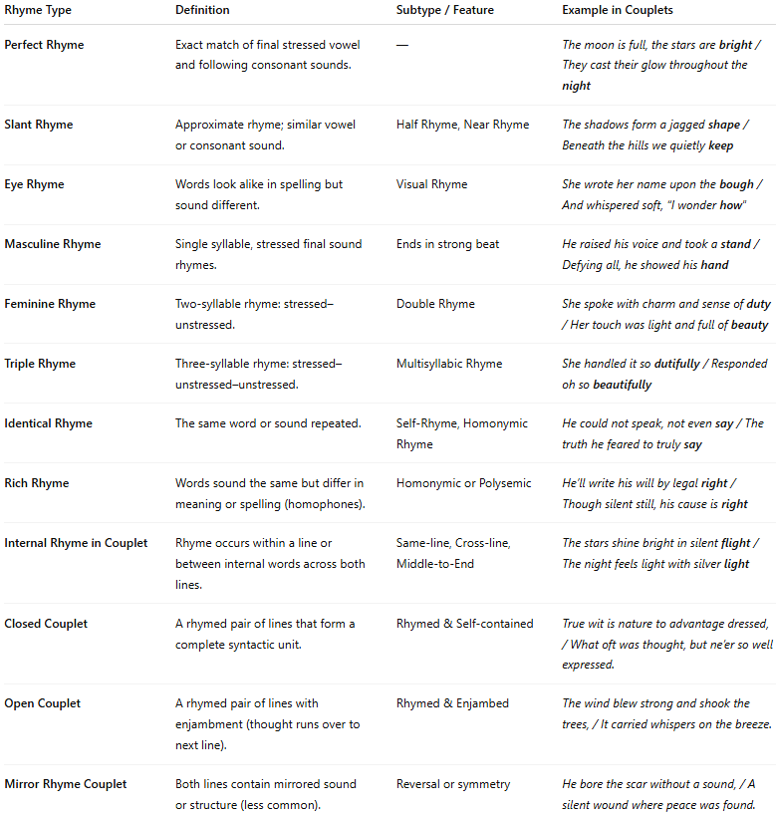

Rhyme Type | Definition | Subtype / Feature | Example in Couplets
Perfect Rhyme | Exact match of final stressed vowel and following consonant sounds. | — | The moon is full, the stars are bright / They cast their glow throughout the night
Slant Rhyme | Approximate rhyme; similar vowel or consonant sound. | Half Rhyme, Near Rhyme | The shadows form a jagged shape / Beneath the hills we quietly keep
Eye Rhyme | Words look alike in spelling but sound different. | Visual Rhyme | She wrote her name upon the bough / And whispered soft, “I wonder how”
Masculine Rhyme | Single syllable, stressed final sound rhymes. | Ends in strong beat | He raised his voice and took a stand / Defying all, he showed his hand
Feminine Rhyme | Two-syllable rhyme: stressed–unstressed. | Double Rhyme | She spoke with charm and sense of duty / Her touch was light and full of beauty
Triple Rhyme | Three-syllable rhyme: stressed–unstressed–unstressed. | Multisyllabic Rhyme | She handled it so dutifully / Responded oh so beautifully
Identical Rhyme | The same word or sound repeated. | Self-Rhyme, Homonymic Rhyme | He could not speak, not even say / The truth he feared to truly say
Rich Rhyme | Words sound the same but differ in meaning or spelling (homophones). | Homonymic or Polysemic | He’ll write his will by legal right / Though silent still, his cause is right
Internal Rhyme in Couplet | Rhyme occurs within a line or between internal words across both lines. | Same-line, Cross-line, Middle-to-End | The stars shine bright in silent flight / The night feels light with silver light
Closed Couplet | A rhymed pair of lines that form a complete syntactic unit. | Rhymed & Self-contained | True wit is nature to advantage dressed, / What oft was thought, but ne’er so well expressed.
Open Couplet | A rhymed pair of lines with enjambment (thought runs over to next line). | Rhymed & Enjambed | The wind blew strong and shook the trees, / It carried whispers on the breeze.
Mirror Rhyme Couplet | Both lines contain mirrored sound or structure (less common). | Reversal or symmetry | He bore the scar without a sound, / A silent wound where peace was found.

